**INTERNATIONAL ISLAMIC UNIVERSITY CHITTAGONG**

**Department of Computer Science & Engineering**

**project Report**

**on**

**classroom device booking platform**

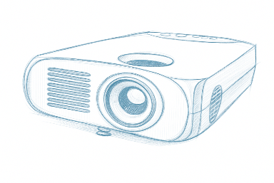

**Submitted To**

Ayesha Julekha

Assistant Lecturer

CSE, IIUC

Semester: 6th Section: 6CF

**Submitted By**

* Nahian Subah Ishma_C223286
* Rehnuma Tasneem_C223288
* Saima Kawsar_C223297

**Course Title : Operating System Lab**

**Course Code : 3632**

**Abstract**

The Classroom Device Booking Platform is designed to solve the common problem of managing shared devices like projectors, laptops, and sound systems in educational institutions. In many universities and colleges, these resources are often booked manually, which leads to scheduling conflicts, double bookings, and inefficient use of time and equipment. This project aims to provide a smart, web-based solution for device booking in a simple and organized way.

The platform allows teachers to book devices in advance using the First-Come, First-Served (FCFS) scheduling algorithm, ensuring a fair allocation process. To help visualize and understand system-level issues, it also includes a deadlock simulation feature that demonstrates resource allocation conflicts based on Operating System concepts.

A key part of the system is its role-based access, where administrators and teachers have different login panels and permissions. Admins can manage and approve bookings, while teachers can submit requests through an easy-to-use interface. The platform is developed using HTML, CSS, and Django/PHP, and focuses on providing a smooth user experience, reducing manual errors, and improving overall resource management in classrooms.

**Contents**

Abstract 1

**01. Introduction** 3

**02. Objectives** 3

03. Purpose of the Project 3

04. Tools and Technologies 4

05. Features 4

06. Algorithm Used 5

First-Come, First-Served (FCFS) Scheduling Algorithm 5

Deadlock Detection Algorithm 5

07. Methodology 6

08. Flowchart 7

09. Result and Outcome 8

10. Future Scope 11

11. Conclusion 11

12. References 11

**01. Introduction**

In many academic institutions, classroom devices such as projectors, sound systems, and laptops are shared among teachers. Without a proper booking system, device allocation often leads to conflicts, overlaps, and inefficiency. The Classroom Device Booking Platform addresses these issues by providing an online solution for booking and managing devices in a systematic way.

The platform incorporates the First-Come, First-Served (FCFS) scheduling algorithm to maintain fairness in allocation. It also includes a deadlock simulation feature, enabling users to understand and visualize resource contention concepts from Operating Systems. With role-based login for administrators and teachers, the system ensures secure access and a clear division of functionalities. Designed with an intuitive interface using internal CSS, the platform minimizes manual errors and ensures smooth scheduling.

**02. Objectives**

The main goals of the **Classroom Device Booking Platform** are:

1. **To_make_device_booking_simple_and_smooth**  
   Help teachers book classroom devices without any confusion or time clashes.
2. **To_keep_the_booking_fair**  
   Use the First-Come, First-Served (FCFS) system so that whoever books first gets the device first.
3. **To_help_admins_understand_conflicts_through_deadlock_simulation**  
   Show how device conflicts can happen if not managed properly, so admins can plan better and avoid problems.
4. **To_give_different_access**   
   Let teachers and admins log in separately and do their own tasks with different options.
5. **To_make_the_platform_easy_to_use**  
   Use simple design and layout so users don’t get confused while using the system.

# **03. Purpose of the Project**

The main purpose of developing the **Classroom Device Booking System** is to solve real problems in managing classroom devices. At our university, booking projectors and multimedia equipment is done manually, which often leads to confusion, double bookings, and wasted class time.

This system offers a web-based solution where teachers can request devices in advance, and admins can approve them using the **First-Come, First-Served (FCFS)** method. It saves time, avoids conflicts, and ensures fair and fast device allocation. We also wanted to apply **Operating System concepts** practically, not just as theory, making our learning more meaningful.

## ****04. Tools and Technologies****

The Classroom Device Booking Platform was developed using the following tools and technologies:

|  |  |
| --- | --- |
| Category | Tools / Technologies & Description |
| Frontend | - **HTML:** Used to create the structure and content of the platform’s web pages.  - **CSS (Internal CSS):** Used for styling, layouts, and visual enhancements. |
| Backend | - **PHP:** Handled server-side logic, processed booking requests, and managed data. |
| Database | - **MySQL:** Stored and managed booking records, user accounts, and device details. |
| Other Tools | - **VS Code:** Code editor used for writing and managing project files.  - **Web Browser (Chrome / Firefox):** Used for testing and running the project. |

**05. Features**

The Classroom Device Booking Platform consists of different modules and functionalities for administrators and teachers, along with a simple, user-friendly interface and a secure backend.

**Modules**

1. Admin Panel
2. Teacher (User) Panel
3. Frontend (User Interface)
4. Backend (Server-side Logic & Database)

**Admin Panel – Key Features**

* Secure login for administrators.
* View and manage all booking requests in a queue using First-Come, First-Served (FCFS) scheduling.
* Simulate deadlock conditions for educational demonstration.
* Display warnings for possible deadlocks.
* Clean and simple dashboard for easy navigation.

**Teacher (User) Features**

* Register and log in securely.
* Request devices (projectors/laptops) by selecting a specific time slot.
* Check the status of requests (Pending / Approved).
* Logout securely and return to the homepage.

**Frontend (User Interface)**

* Smart and responsive index page with Sign Up and Login buttons.
* Simple, modern layout designed with internal CSS.
* Separate dashboards for administrators and teachers to avoid role conflicts.

**Backend (PHP + MySQL)**

* FCFS scheduling logic implemented for fair device allocation.
* Deadlock detection simulation included in the admin panel.
* Secure form handling to prevent invalid data submission.
* Role-based access control and session management for security.

**06. Algorithm Used**

In our project, we have mainly used two algorithms to handle device booking and to show some important operating system concepts.

**First-Come, First-Served (FCFS) Scheduling Algorithm**

This algorithm works in a very simple way, whoever books first, gets processed first. No one can skip the line. If a booking request comes earlier, it will be checked and decided before any later requests. The admin also cannot take any action (approve or reject) on a later request until they have decided on the earlier one. This system keeps the booking process fair and clear for everyone.

* **Same Date Bookings:** If two or more bookings are for the same date, then the booking time decides the order, the earlier time gets priority.
* **Different Date Bookings:** If bookings are on different dates, then the date itself decides the order, earlier dates are processed first.

**Deadlock Detection Algorithm**

We have also added a deadlock detection feature in the admin panel. This is to show how a system can get stuck when two or more people try to use the same limited resource at the same time.

* If two or more users request the **same device** for the **same time slot**, the system marks it as a possible deadlock.
* A warning is shown to the admin so they know there is a conflict.
* This way, the admin can solve the problem before the system gets stuck.

# **07. Methodology**

The Classroom Device Booking System follows a simple and structured methodology:

**System Initialization:**

* Teachers register through the website by providing their details, which are stored in the database.
* Admin accounts are created manually in the database for security purposes.
* Both teachers and admins must log in to access their respective panels.

**Booking Setup:**

* Teachers view available devices and select booking date and time.
* Booking requests are saved in the database with a “Pending” status.

**Booking Management:**

* Admin views pending requests and processes them using the **First-Come, First-Served (FCFS)** method.
* Admin approves or rejects each request.
* After approval or rejection, admin can **delete the booking record** if needed.

**Conflict Handling:**

* Conflict detection is performed during admin review.
* During conflict resolution; If a booking request conflicts with an existing booking, the admin resolves the conflict before making a decision.

**Booking Completion:**

* In the teacher panel, the booking status (Approved or Rejected) is displayed once processed by the admin.
* Teachers cannot cancel bookings once submitted.

This methodology ensures a smooth and organized booking process by allowing teachers to easily request devices and enabling admins to efficiently manage and resolve bookings. With clear role separation, conflict handling, and secure account management, the system provides a reliable and user-friendly solution for classroom device allocation.

# **08. Flowchart**

# **09. Result and Outcome**

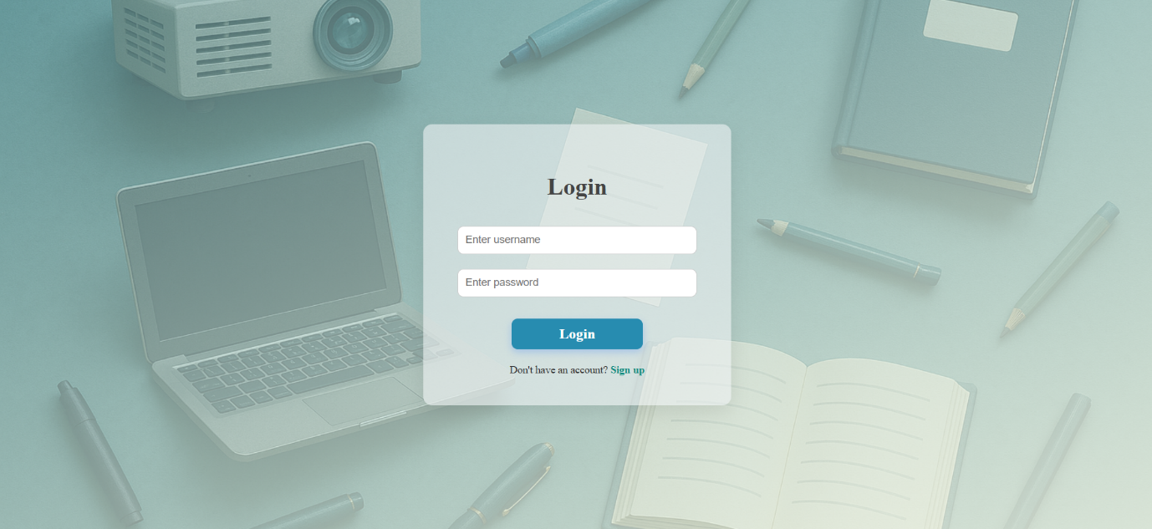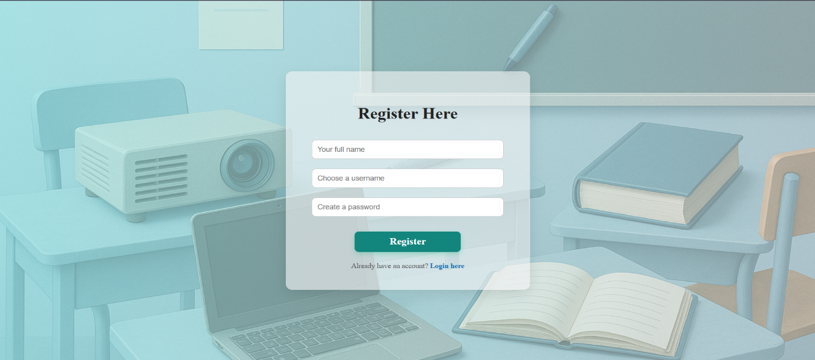

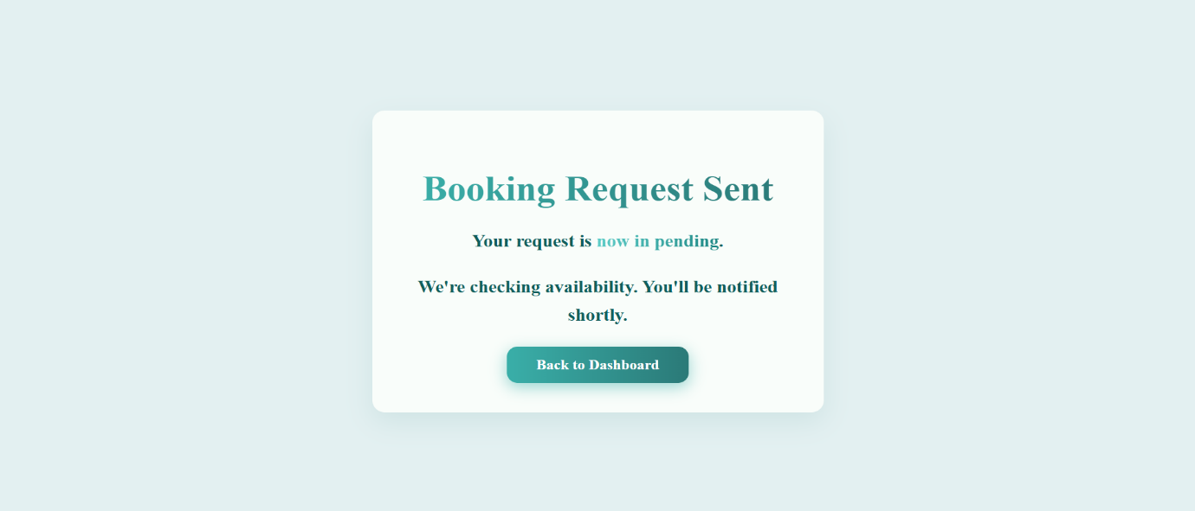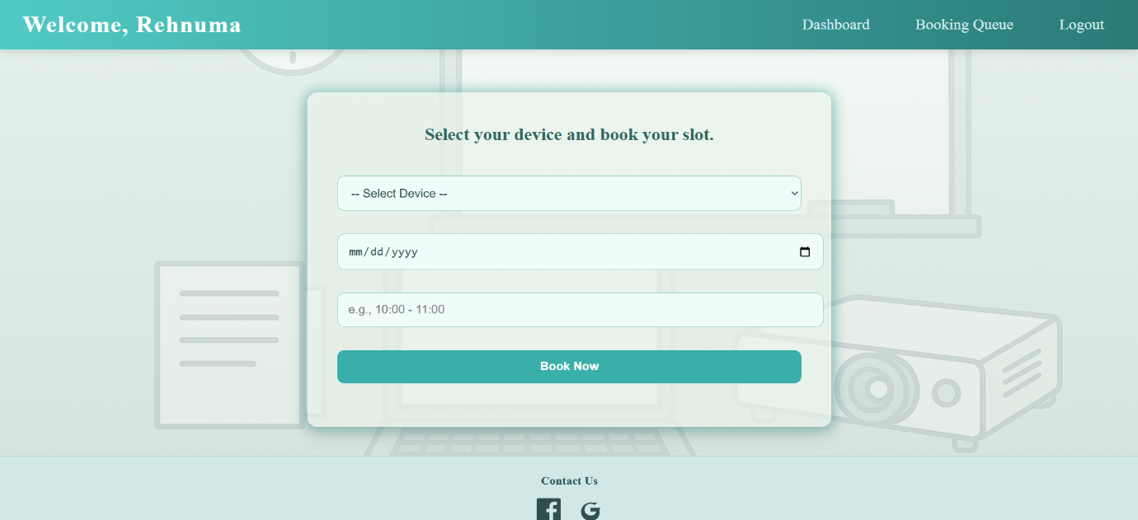

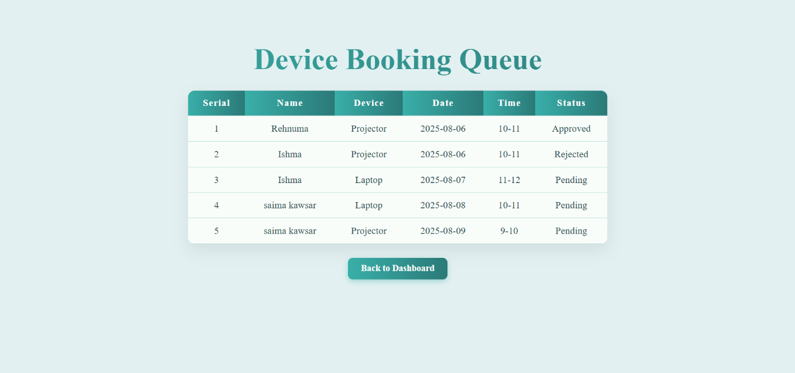

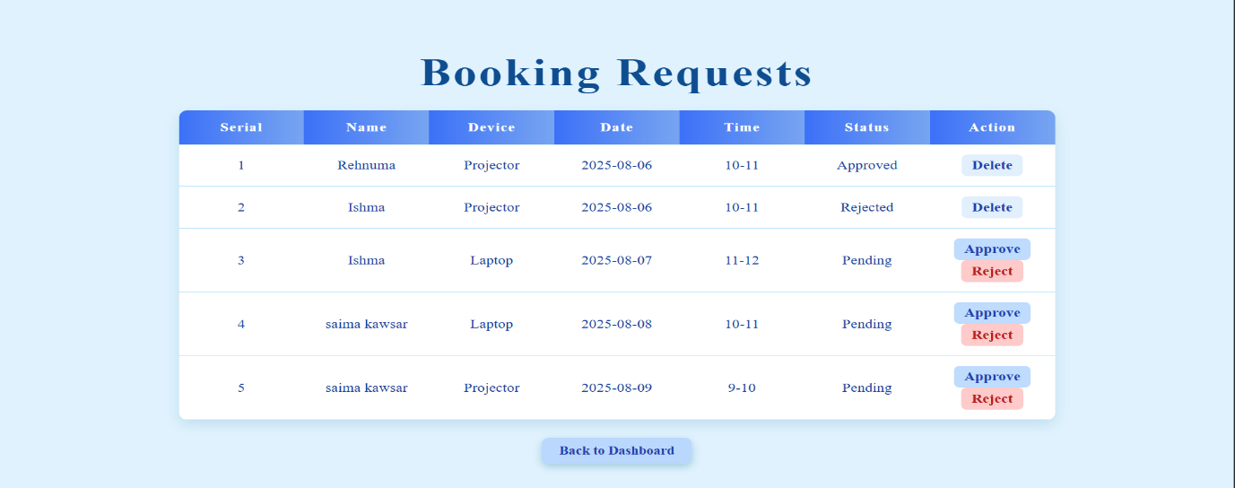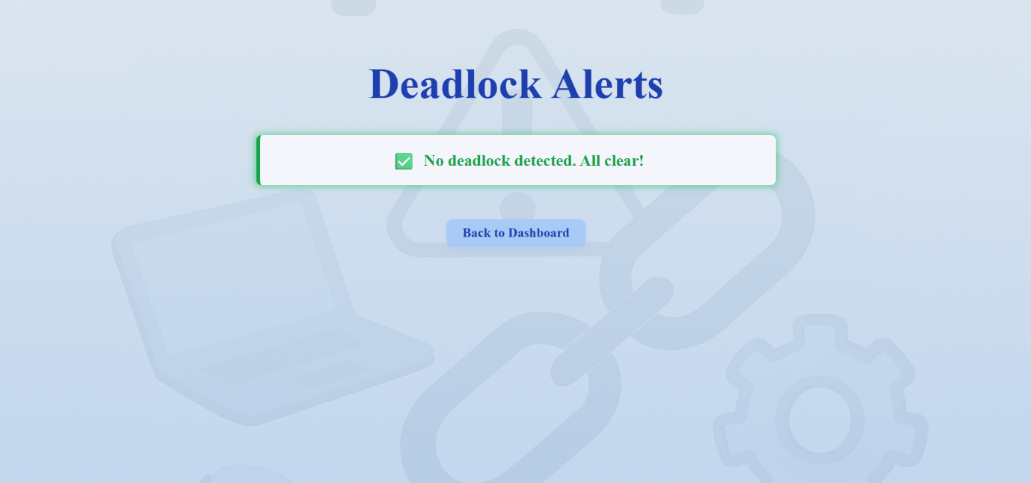

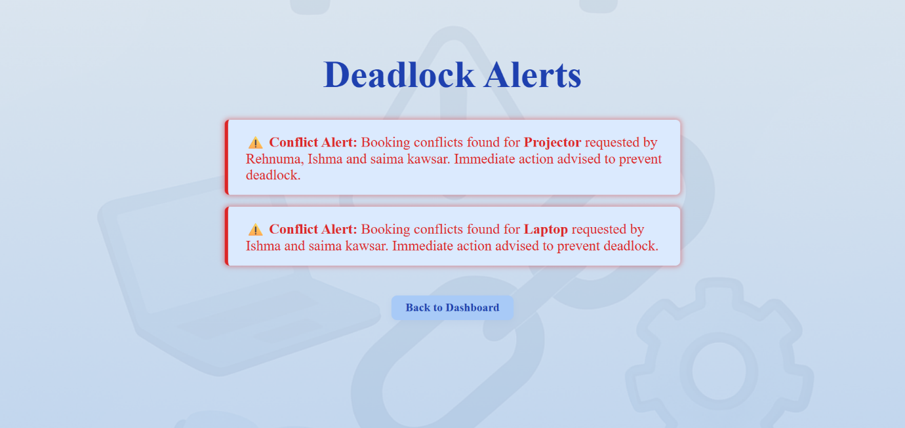

# **10. Future Scope**

The Classroom Device Booking System can be further improved and expanded with additional features to enhance usability and efficiency. Possible future developments include:

* **Automated Notifications:** Sending email or SMS alerts to teachers when their booking is approved or rejected.
* **Multiple Scheduling Algorithms:** Adding options like Priority Scheduling or Round Robin for more flexible booking management.
* **Advanced Search and Filters:** Allowing teachers to quickly find available devices based on date, time, or type.
* **Mobile-Friendly Interface:** Optimizing the system for mobile devices to allow bookings on the go.
* **Analytics and Reports:** Providing admins with detailed usage reports and statistics on device demand.
* **Integration with Calendar Apps:** Syncing approved bookings with Google Calendar or other scheduling tools.

# **11. Conclusion**

The Classroom Device Booking System successfully streamlines the process of reserving classroom devices, ensuring efficient allocation and management. By allowing teachers to submit booking requests and enabling admins to approve, reject, or delete them, the system maintains fairness and organization. Features like conflict resolution, secure login, and clear booking status updates make the platform reliable and easy to use. Overall, the project meets its goal of providing a simple, effective, and user-friendly solution for managing device bookings in an academic environment.

# **12. References**

1. Silberschatz, A., Galvin, P. B., & Gagne, G. (2018). Operating System Concepts (10th Edition). Wiley.
2. GeeksforGeeks - Deadlock in Operating System:   
   <https://www.geeksforgeeks.org/deadlock-in-operating-system/>
3. TutorialsPoint - Operating System & Scheduling Algorithms: <https://www.tutorialspoint.com/operating_system/index.htm>
4. W3Schools - PHP Tutorial: <https://www.w3schools.com/php/>
5. GeeksforGeeks - First-Come, First-Served Scheduling: <https://www.geeksforgeeks.org/first-come-first-served-fcfs-scheduling/>